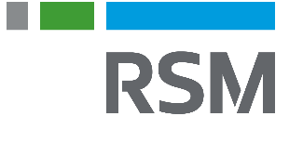
Lori Anne Johnston
Manager, Washington National Tax
RSM US LLP
Washington, DC
lorianne.johnston@rsmus.com
+1 202 370 8178
Summary of experience
Lori Anne is a member of RSM’s Washington National Tax practice, specializing in accounting methods and periods. Lori Anne advises clients on a variety of tax technical issues in the accounting methods and periods functional area, including the timing of income and expense recognition, the treatment of tangible and intangible assets, choice and application of overall methods of accounting (cash, accrual, and hybrid), depreciation and amortization, as well as limited assistance with inventory/UNICAP issues. Lori Anne also provides tax technical and procedural guidance for requests to change accounting methods or periods. While accounting methods and periods is Lori Anne’s primary focus, she has also developed expertise in certain niche areas. These include S corporation shareholder basis and AAA as well as medical component calculations for retirement communities.
Lori Anne welcomes all questions, from the simplest of issues to the very complex. Lori Anne loves tackling previously unasked or unanswered questions and has a particular fondness for uncommon transactions, special methods, and all variety of atypical issues.
Before joining RSM, Lori Anne taught Professional Ethics and Business Law at her alma mater, the University of Southern Mississippi.
Professional affiliations and credentials
Certified Public Accountant
American Institute of Certified Public Accountants
Alabama Society of Certified Public Accountants
- State Bar of Indiana
- State Bar of Mississippi
Education
Juris Doctorate, Indiana University-Bloomington
Master of Professional Accountancy, University of Southern Mississippi
- Bachelor of Arts, English Literature, University of Southern Mississippi

